**July**

14

**Arena Multimedia Class of 2014**

YERA GLASSWARE PROJECT

*Trang Thien Le (Team Leader) & Tan Hung Phan*

*Bring a brand new identity for the glassware company by building up a new identity for glassware industry*

08

**Fall**

# 

* Project Topic: YERA Glassware
* Team members:

Trang Thien Le

Tan Hung Phan

* Supervisor:

Nguyen Thanh Minh

* Date of start: 10th June, 2014
* Date of end: 16th July, 2014

*With Special Thanks To:*

* Mr. Nguyen Thanh Minh, our instructor and supervisor, who gives us on-going support and dedicated supervision.
* BATCH 22a classmates for the ideas and suggestions given for this project.
* My brother for his guidance in pursing this new career track and enabling me to finish this diploma. Without his financial support, I would have not been able to finish this course. Also, I would like to thanks my mother and father who always encourage me to do whatever that I am passionate about.

*Project Leader*

Trang Thien Le

Table of Contents:

1. Introduction
2. Logo and Brand Indentity
3. Main colors and fonts
4. Design and development softwares
5. Analysis of Website

1, The Intro page

2, Main Pages

1. Layouts
2. Flow Chart
3. Panning
4. Checklist
5. Shooting image
6. Template Code
7. CSS Style
8. Conclusion
9. **Introduction**

This project is conducted as a partial requirement for the course Diploma in Multimedia. It was carried out by Ms. Le Thien Trang (Team leader) and Mr. Phan Hung Tan. The team started the project in early June and finished it within a month.

The project is to design the website for YERA, a glassware company, which designs, produces, and markets a wide range of handmade glassware products for the pleasant industry. Based in the United Kingdom, the products are sold worldwide through channels of distribution, and private label design.

We looked at this project on the marketing communications perspective. Generally, companies communicate with their customers through paid, owned and earn media channels (Burcher, 2012). Website is part of the owned one. We assumed that the company was already performing well in the market but its owned channel still left some gap for further improvement. The online identity was still weak and needed a fresh look to provide a more user-friendly website. We created a strong visual identity for the company building a new logo & landing page.

The next part of this report will provide a more in-depth analysis about the website and design. Also, it will highlight elements that make its identity unique to stand out in the market. We hope that by giving a fresh touch, feel-good elements into design, the company could communicate better with the customers, drive the sales and enhance the return on investment.

1. **Logo and Brand Identity:**

YERA Glassware's Logo has the symbol of a glass designed to fit with the letter Y, the first letter of the company name. We decided that the main color is red which is expected to make the logo look more outstanding but still has a fell-good element to it.

Also, when dicussed, we agreed that the cocktail glass, which always represents poshness and high-class quality, will be the perfect symbol for the company and its services. Over the years, the company has developed a clientele of some of the world’s finest hotels and restaurants. With many years of expertise within the hospitality industry, YERA understands the importance of quality, durability, and functionality. The company does not just sell glassware; it creates concepts for a tabletop and brand solutions.

1. **Main Colors and Fonts**

Our group use red color- “#e31e25” for each site with crystal patterns, which makes our website templates more vivid and attract client’s attention. Moreover, the font Schadow BT Roman brings comfortable looks, which makes it easier for the clients to read.

1. **Design and Development Software**

A wide range of software has been used to develop the website. They include, but not limit to**:**

-Adobe Photoshop CS6

-Adobe Illustrator CS6

-Adobe Dreamweaver CS6

-Adobe Flash Professional CS6

-Corel Draw

-Adobe Audition CS6

-Microsoft Word 13

1. **Analysis of the Website:**

**5.1. The Intro Page:**

The intro page (or landing page) provide a quick view of the company, providing customers with short but precise information about its services. The intro page is also very customized. It has volume function, play, skip, pause buttons; so that potential customers could change it the way they want.

**5.2. The Website Contains 7 Main Pages:**

**5.2.1 Home page:**

In this most important website, after lots of consultancy, we chose this page as the main theme colour, inspired by the colour of the flower fuchisa, for the home page. Twinkling glass flakes in the background also highlight the featured images and make them more visually attractive to customers. Additionally, we wanted to target both existing and potential customers.

According to Nielsen (2011), nowadays online customers never stay more than 20 seconds on a shopping webpage. Therefore, we had to work how to impress web browsers as soon as they see the page by good images giving contain about how much benefit glassware goods could bring to a family. More importantly, not only does Yera have glassware products useful and convenient, but also it is the symbol of eternal beauty. Among the web browsers, many of them may have been loyal ones to the company and only would like to have an update on new products and make purchase decision. We introduced new collections right on the home page so that they do not have to go through much further inside the website or use search tool.

**5.2.2 About Us Page:**

For the second page, we look at this on the perspective of Public Relations. We had to provide factual but positive information about the company and also leave contact details in case journalists or any media outlets can find a good news angle from the company, so that they could contact us and generate good media coverage.

In this page, we give some good background information about the company and what makes us unique. The company's mission is also covered here. Each piece of YERA GLASS is 100% hand-crafted using traditional processes that require extraordinary skills and patience. Each item is unique, with variations that reveal the beauty of the material and the skilled hand of the craftsman. YERA’s range of shaped glassware capabilities is one of the most extensive in the industry.

**5.2.3. Product Page:**

YERA Glassware has a wide range of products but we specialize in the upper class market. In its recent business strategy, the company would like to develop more high quality products to meet the gap in this extended market. Products will be listed in alphabet order with a search tool if customers already know the name of the products they would like to know more information about.

**5.2.4. Site Map Page:**

This very interactive page will give customers a good structure of the website with some visual effect to aid the web experience (below) (NHO CHEN ANH CUA PAGE VAO)

**5.2.5. Registration Page:**

Now that customers could purchase products right on the website, they have lots of options to choose from. After orders are made, they will be requested to register to become members. They will be notified that information they give out won't be sent to any third parties and only be used for promotion purposes to provide a better customer service. The interface is simple and light, they can register within a minute or so.

**5.2.6. Contact Us Page:**

We understand that, operating in consumer industry, having a 24/7-helpline number is a must. Therefore, the website is purposely created to provide customers with further assistance in either purchasing, online purchasing to complaints. We also include an online map with address on it so that they could come meet our friendly staff at any time.

**5.2.7. Gallery Page:**

In this gallery, all products will be presented including glass-set, kitchenware, glass accessories. With motion effect, customers could watch through the whole gallery without moving the cursor. The team would consult with the marketing team to have high quality/professional images of products and put them on the gallery to give a more visually attractive look to products.

1. **Layouts**

* Home Page:

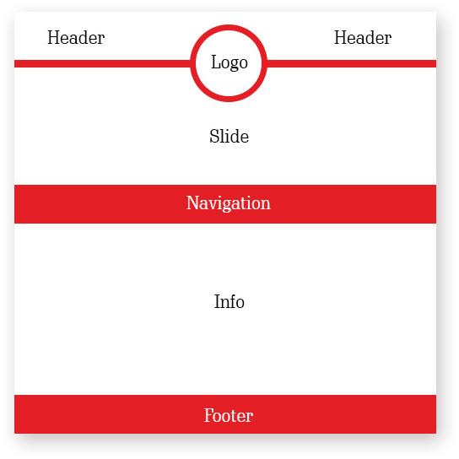

-Other pages

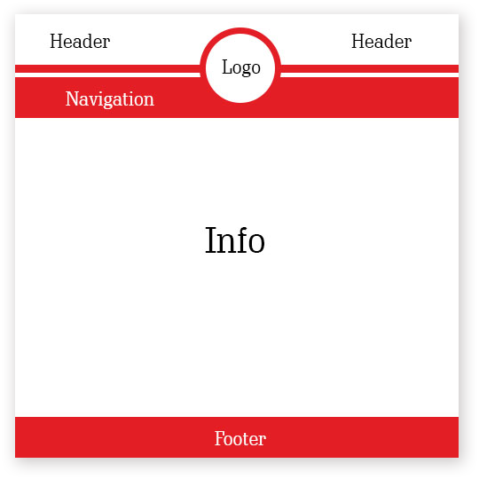

1. **Flowchart**

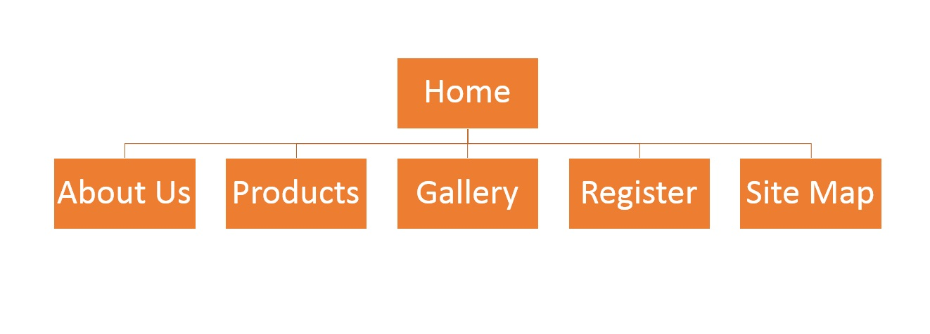

1. **Planning**

|  |  |  |  |  |  |  |
| --- | --- | --- | --- | --- | --- | --- |
| Project Ref.no | | **Activity Plan** | Date of Prepare of Activity Plan | | | |
|
| Sr.No | YERA Glassware | Planned Start Date(dd/mm) | Actual Start Date | Actual Days | Team Mate Name | Status |
|  | Searching data and information on the Internet | 06/06 | 07/06 | 2 | Trang, Tan | Complete |
|  | Analyses problem | 07/06 | 08/06 | 2 | Trang ,Tan | Complete |
|  | Design logo | 08/06 | 13/06 | 6 | Tan | Complete |
|  | Design Homepage | 13/06 | 15/06 | 3 | Trang,Tan | Complete |
|  | Design Pages Craftmap ,Contact Us | 16/06 | 20/06 | 5 | Trang, Tan | Complete |
|  | Design pages to introduction products | 21/06 | 26/06 | 6 | Trang, Tan | Complete |
|  | Making animation and intro page | 27/06 | 30/06 | 4 | Tan | complete |
|  | Write code for Sitemap | 1/07 | 10/07 | 10 | Trang | Complete |
|  | Write page .CSS | 1/07 | 10/07 | 10 | Trang | Complete |
|  | Write Document for e-Project | 14/07 | 14/07 | 1 | Trang | Complete |
|  | Complete website and Corrects | 15/07 | 15/07 | 1 | Trang, Tan , Mr. Minh | Complete |

1. **Checklist**

Checklist for Validation

|  |  |  |
| --- | --- | --- |
| **Sr. No.** | **Aspect tested** | **Remarks** |
| 1. | Fields in forms should not be null | √ |
| 2. | All numeric fields should have a default value of 0 | √ |
| 3. | Are all the program codes working? | √ |
| 4. | The site name for publishing is unique | √ |
| 5. | Hyperlinks have tool tip texts | √ |
| 6. | Home page has only forward link | √ |

1. 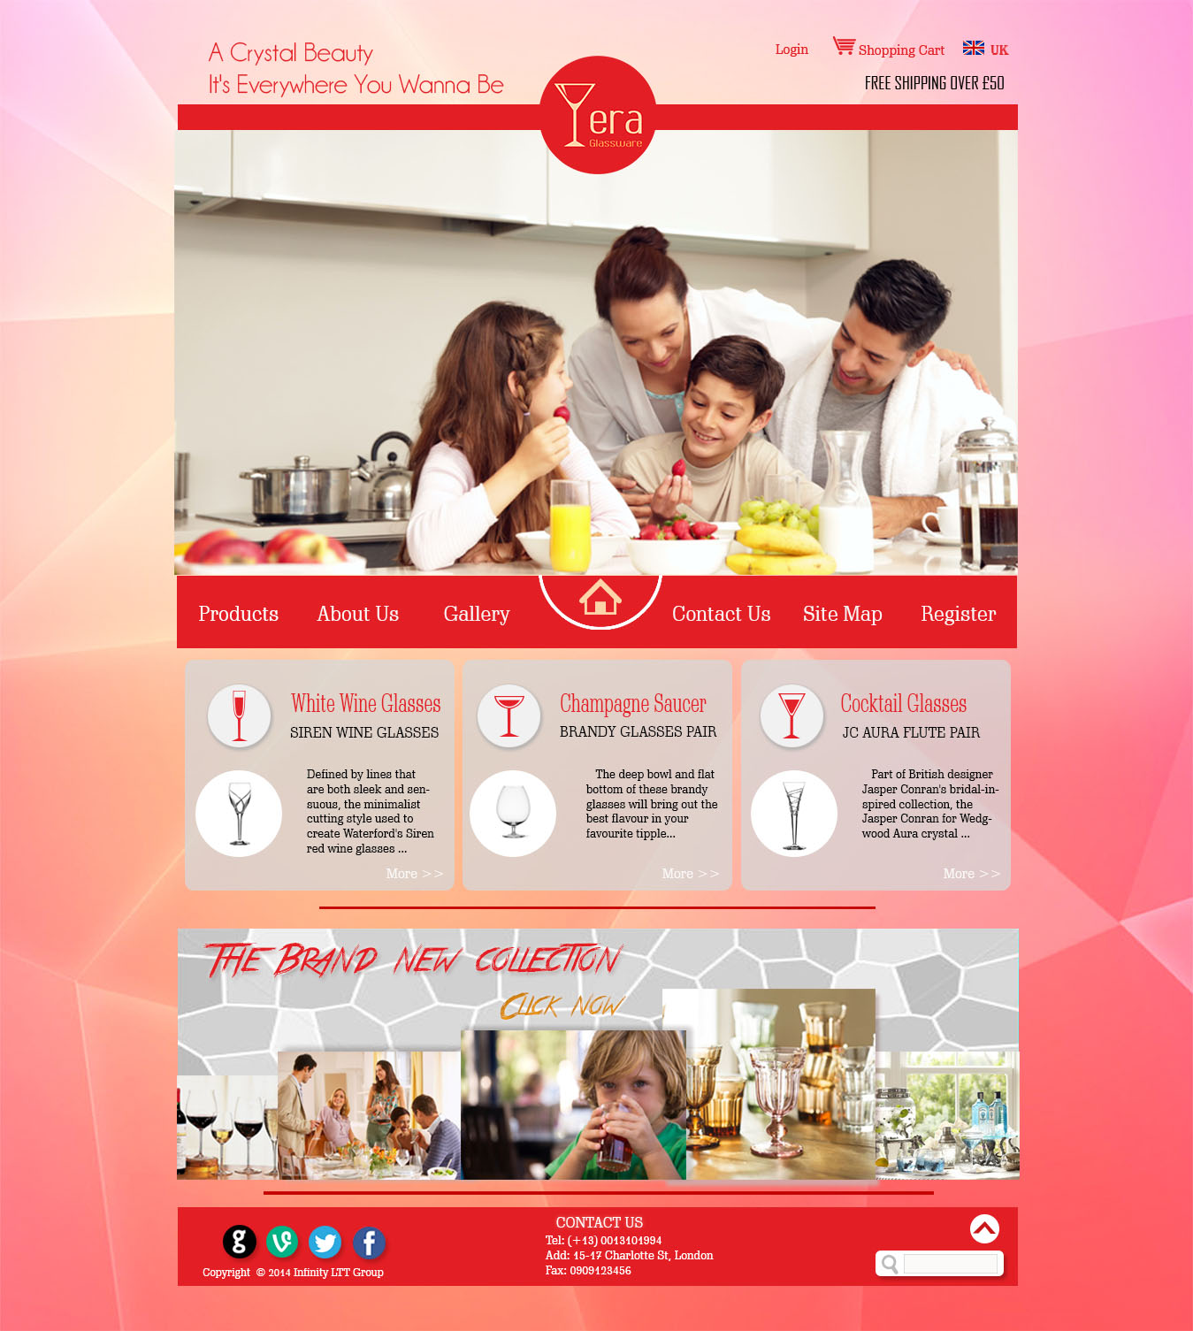**Shooting image**

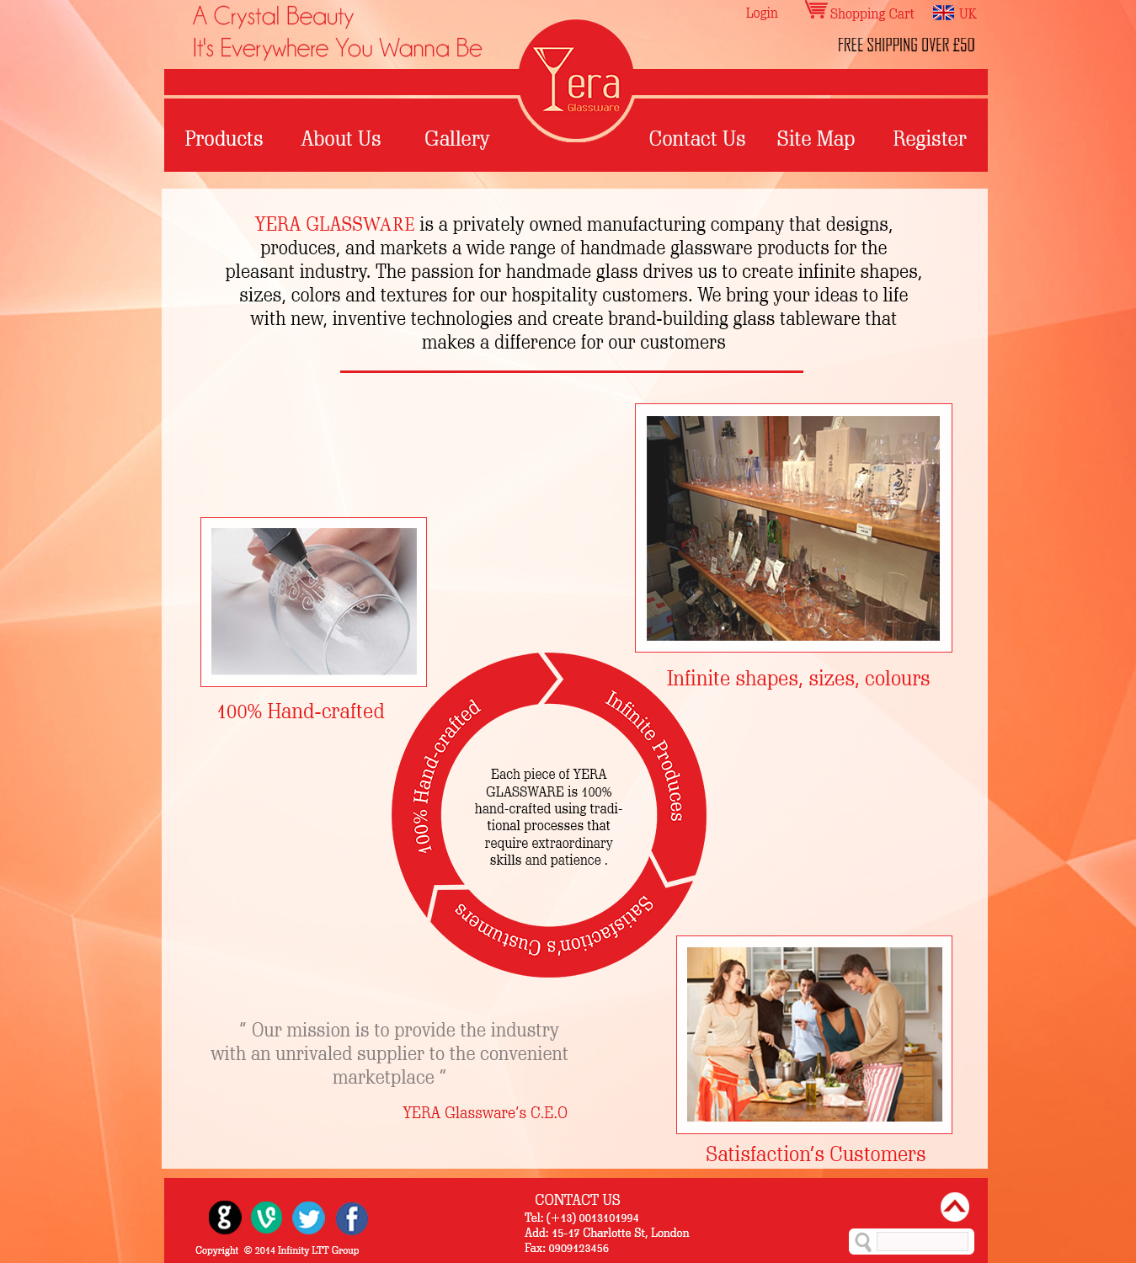

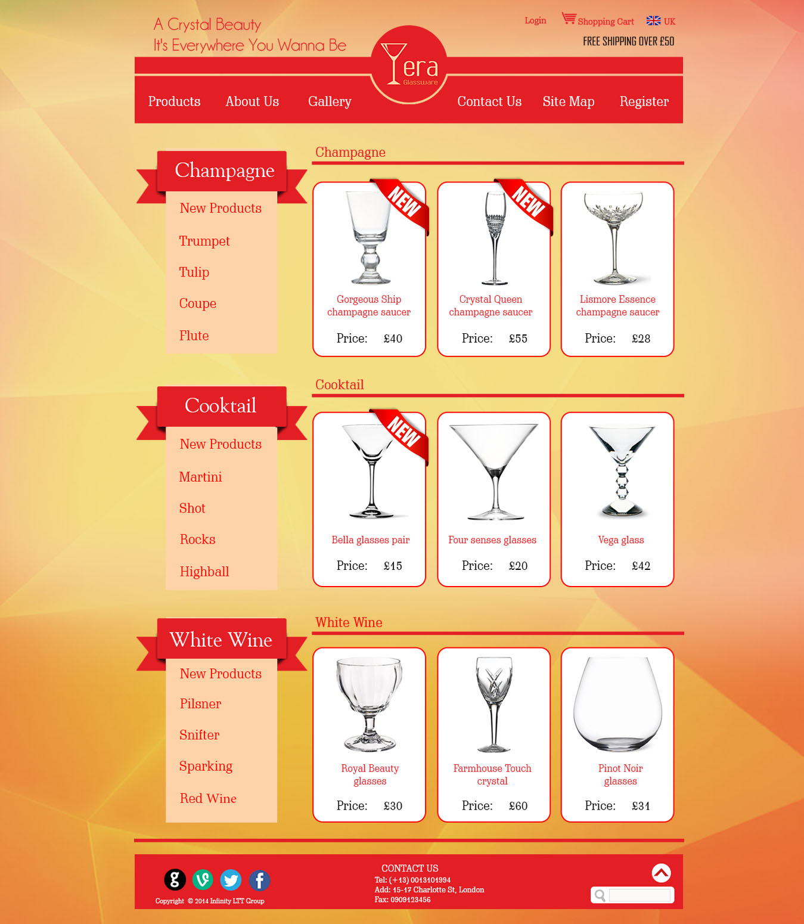

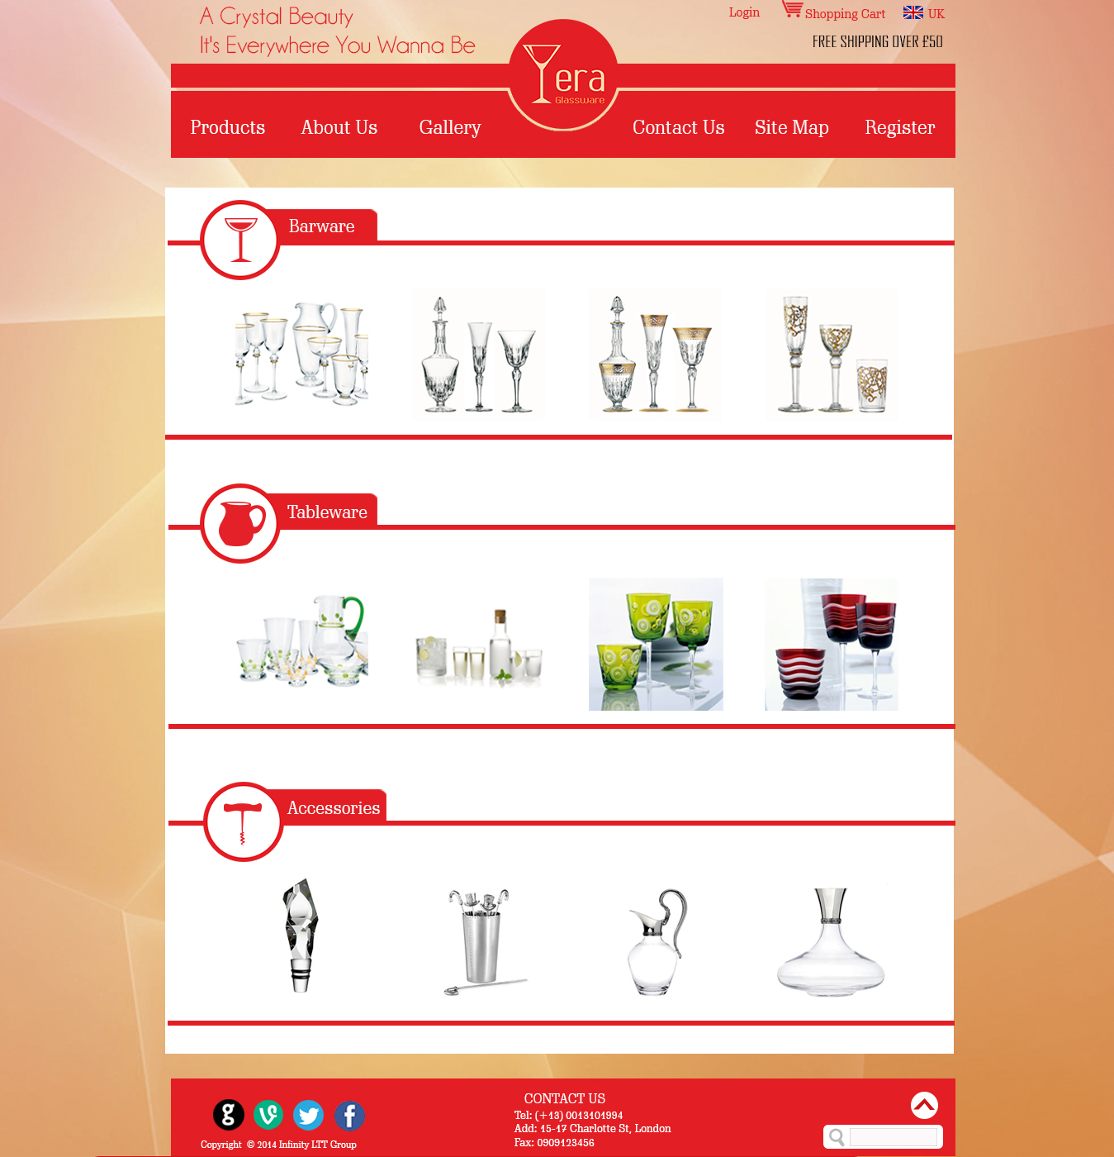

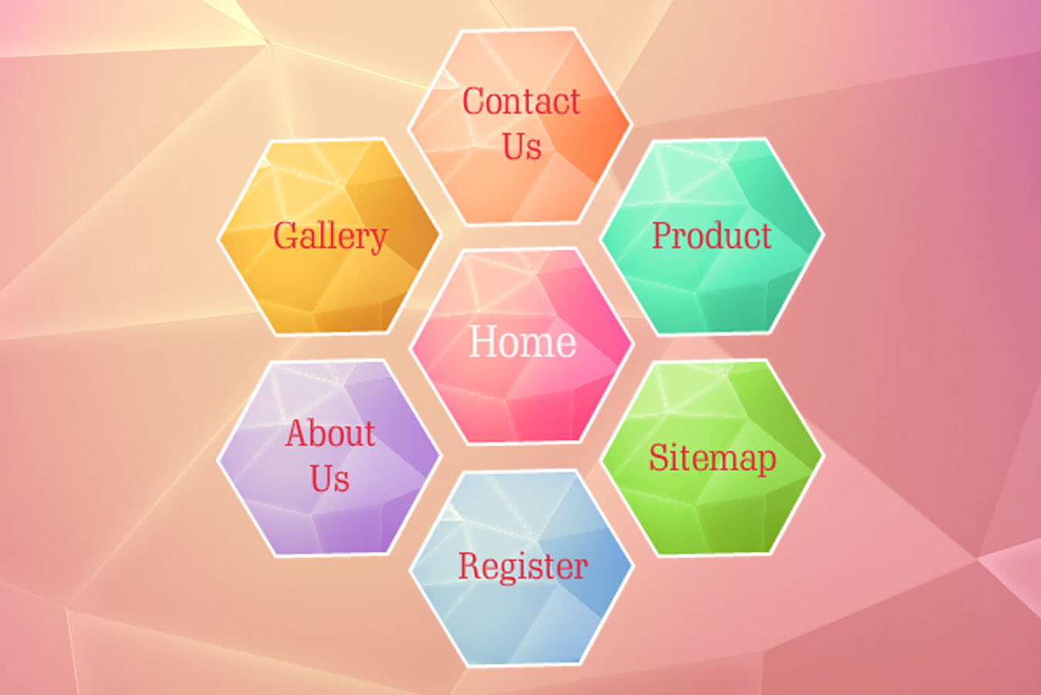

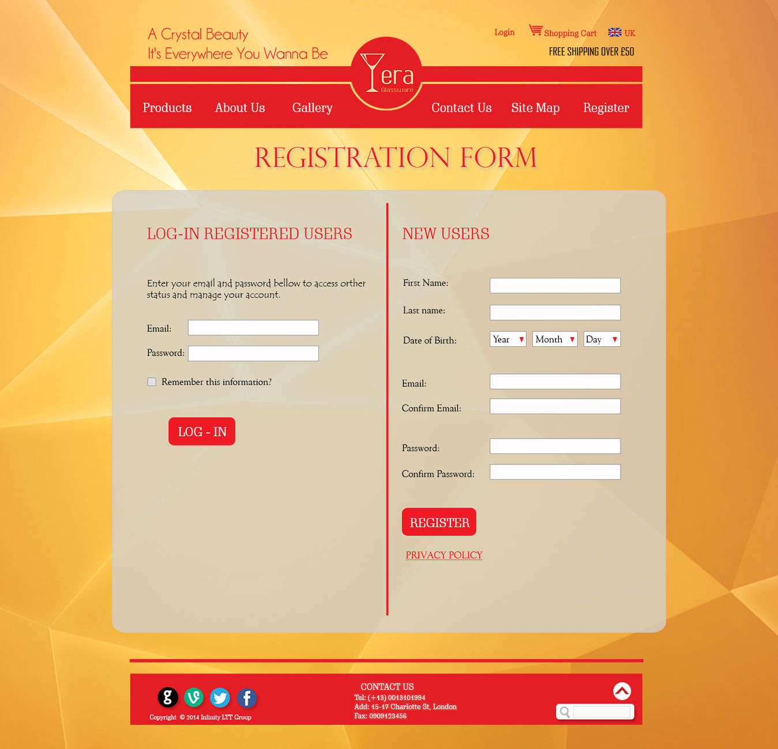

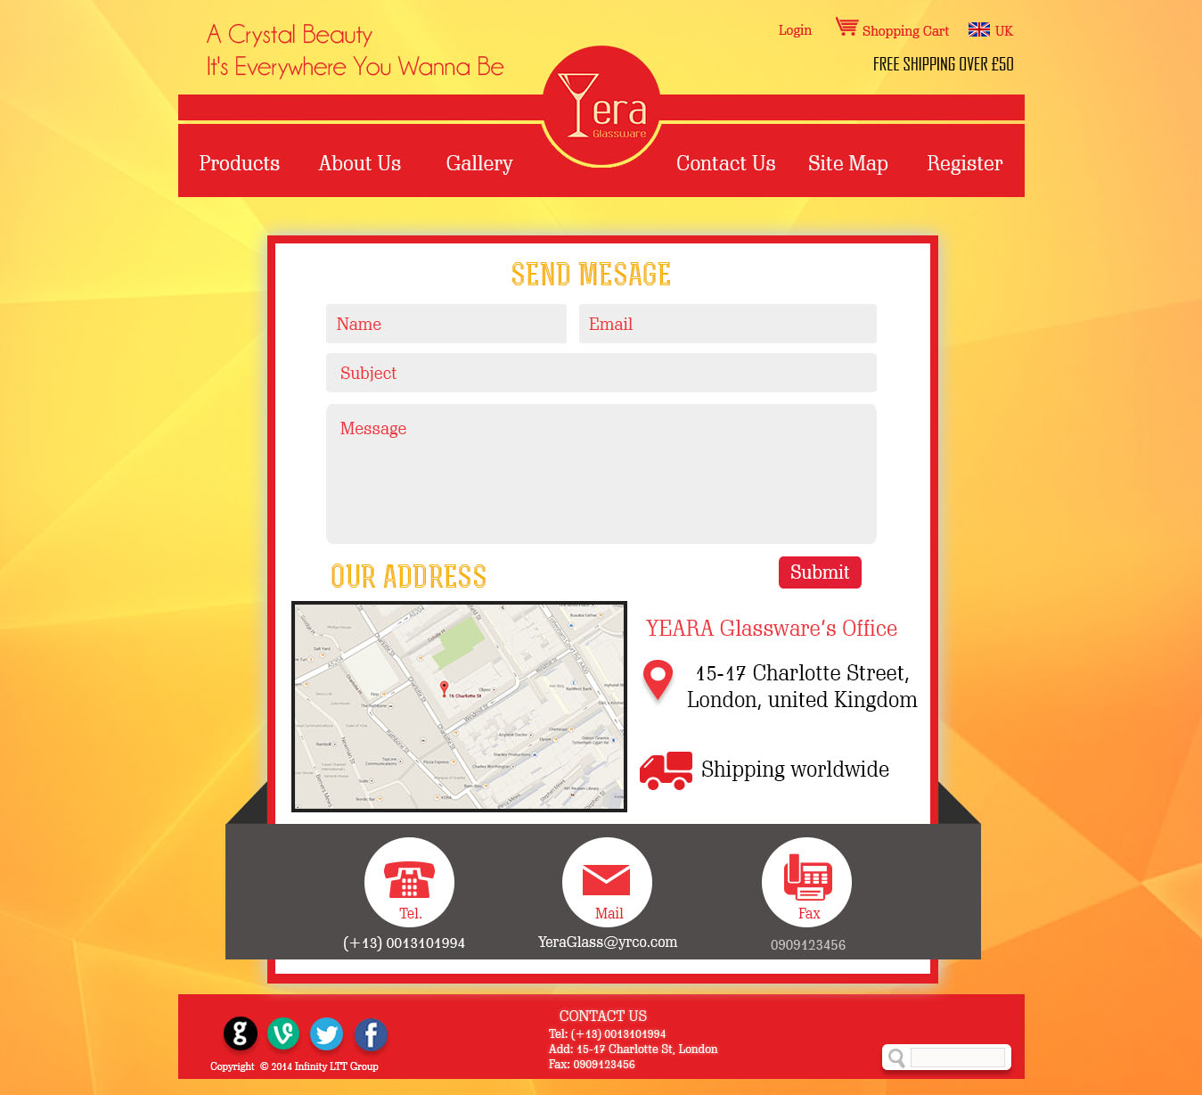

1. **Template code**

<!DOCTYPE html PUBLIC "-//W3C//DTD XHTML 1.0 Transitional//EN" "http://www.w3.org/TR/xhtml1/DTD/xhtml1-transitional.dtd">

<html xmlns="http://www.w3.org/1999/xhtml">

<head>

<meta http-equiv="Content-Type" content="text/html; charset=utf-8" />

<title>Home</title>

<link href="CSS/style1.css" rel="stylesheet" type="text/css" />

<link rel="shortcut icon" href="images/LOGO.ico">

</head>

<body>

<div id="header">

<a id="top"></a>

<div id="mHeader">

<div class="hLeft">

<img src="images/Slogan.png" width="335" height="63" />

</div>

<div class="hRight">

<ul>

<li><a href="regis.html">Login</a></li>

<li><img src="images/shoppingcart.png" width="26" height="21" /><a href="#">Shopping Cart</a></li>

<li><img src="images/flag.png" width="24" height="16" /><a href="#">UK</a></li>

</ul>

<p>FREE SHIPPING OVER £50</p>

</div>

<div class="logo"><object classid="clsid:d27cdb6e-ae6d-11cf-96b8-444553540000" width="134" height="134" id="LOGO DONG1" align="middle">

<param name="movie" value="LOGO DONG1.swf" />

<param name="quality" value="high" />

<param name="bgcolor" value="#ffffff" />

<param name="play" value="true" />

<param name="loop" value="true" />

<param name="wmode" value="transparent" />

<param name="scale" value="showall" />

<param name="menu" value="true" />

<param name="devicefont" value="false" />

<param name="salign" value="" />

<param name="allowScriptAccess" value="sameDomain" />

<!--[if !IE]>-->

<object type="application/x-shockwave-flash" data="LOGO DONG1.swf" width="134" height="134">

<param name="movie" value="LOGO DONG1.swf" />

<param name="quality" value="high" />

<param name="bgcolor" value="#ffffff" />

<param name="play" value="true" />

<param name="loop" value="true" />

<param name="wmode" value="transparent" />

<param name="scale" value="showall" />

<param name="menu" value="true" />

<param name="devicefont" value="false" />

<param name="salign" value="" />

<param name="allowScriptAccess" value="sameDomain" />

<!--<![endif]-->

<a href="http://www.adobe.com/go/getflash">

<img src="http://www.adobe.com/images/shared/download_buttons/get_flash_player.gif" alt="Get Adobe Flash player" />

</a>

<!--[if !IE]>-->

</object>

<!--<![endif]-->

</object></div>

</div>

<div class="line1" /></div>

<div class="slide1"><object classid="clsid:d27cdb6e-ae6d-11cf-96b8-444553540000" width="960" height="503" id="slide" align="middle">

<param name="movie" value="slide.swf" />

<param name="quality" value="high" />

<param name="bgcolor" value="#ffffff" />

<param name="play" value="true" />

<param name="loop" value="true" />

<param name="wmode" value="transparent" />

<param name="scale" value="showall" />

<param name="menu" value="true" />

<param name="devicefont" value="false" />

<param name="salign" value="" />

<param name="allowScriptAccess" value="sameDomain" />

<!--[if !IE]>-->

<object type="application/x-shockwave-flash" data="slide.swf" width="960" height="503">

<param name="movie" value="slide.swf" />

<param name="quality" value="high" />

<param name="bgcolor" value="#ffffff" />

<param name="play" value="true" />

<param name="loop" value="true" />

<param name="wmode" value="transparent" />

<param name="scale" value="showall" />

<param name="menu" value="true" />

<param name="devicefont" value="false" />

<param name="salign" value="" />

<param name="allowScriptAccess" value="sameDomain" />

<!--<![endif]-->

<a href="http://www.adobe.com/go/getflash">

<img src="http://www.adobe.com/images/shared/download_buttons/get_flash_player.gif" alt="Get Adobe Flash player" />

</a>

<!--[if !IE]>-->

</object>

<!--<![endif]-->

</object> </div>

</div>

<div id="nav">

<div id="mNav">

<div class="nLeft">

<ul>

<li><a href="Product.html">Products</a></li>

<li><a href="AboutUs.html">About Us</a></li>

<li><a href="Gallery.html">Gallery</a></li>

</ul>

</div>

<div class="nRight">

<ul>

<li><a href="ContactUs.html">Contact Us</a></li>

<li><a href="SiteMap.html">Site Map</a></li>

<li><a href="Regis.html">Registration</a></li>

</ul>

</div>

<a href="home.html"><img src="images/homeicon.png" width="41" /></a>

</div>

</div>

<div id="info">

<div id="mInfo">

<div class="fbox">

<div class="sbox">

<div class="top">

<div class="glassi"><img src="images/glassicon1.png" width="79" height="79" /></div><div class="text"><p><a href="Product.html">WHITE WINE GLASSES</a></p><br/><p>SIREN WINE GLASSES</p></div>

</div>

<div class="bottom">

<div class="glassr"><img src="images/glassR1.png" width="98" height="98" /></div><p> Defined by lines that are both sleek and sensuous, the minimalist cutting style used to create Waterford's Siren red wine glasses ...</p>

</div>

<div class="more"><a href="Product.html">More>></a></div>

</div>

<div class="sbox2">

<div class="top">

<div class="glassi"><img src="images/glassicon2.png" width="79" height="79" /></div><div class="text"><p><a href="Product.html">BRANDY GLASSES PAIR</a></p><br/><p>CHAMPAGNE SAUCER</p></div>

</div>

<div class="bottom">

<div class="glassr"><img src="images/glassR2.png" width="98" height="98" /></div><p> The deep bowl and flat bottom of these brandy glasses will bring out the best flavour in your favourite tipple, it's a beautiful creature...</p>

</div>

<div class="more"><a href="Product.html">More>></a></div>

</div>

<div class="sbox">

<div class="top">

<div class="glassi"><img src="images/glassicon3.png" width="79" height="79" /></div><div class="text"><p><a href="Product.html">JC AURA FLUTE PAIR</a></p><br/><p>COCKTAIL GLASSES</p></div>

</div>

<div class="bottom">

<div class="glassr"><img src="images/glassR3.png" width="98" height="98" /></div><p> Part of British designer Jasper Conran's bridal-inspired collection, the Jasper Conran for Wedgwood Aura crystal,this glass will...</p>

</div>

<div class="more"><a href="Product.html">More>></a></div>

</div>

</div>

<img class="line3" src="images/line3.jpg" width="629" height="3" />

<object classid="clsid:d27cdb6e-ae6d-11cf-96b8-444553540000" width="950" height="300" id="HOME" align="middle">

<param name="movie" value="HOME.swf" />

<param name="quality" value="high" />

<param name="bgcolor" value="#ffffff" />

<param name="play" value="true" />

<param name="loop" value="true" />

<param name="wmode" value="transparent" />

<param name="scale" value="showall" />

<param name="menu" value="true" />

<param name="devicefont" value="false" />

<param name="salign" value="" />

<param name="allowScriptAccess" value="sameDomain" />

<!--[if !IE]>-->

<object type="application/x-shockwave-flash" data="HOME.swf" width="950" height="300">

<param name="movie" value="HOME.swf" />

<param name="quality" value="high" />

<param name="bgcolor" value="#ffffff" />

<param name="play" value="true" />

<param name="loop" value="true" />

<param name="wmode" value="transparent" />

<param name="scale" value="showall" />

<param name="menu" value="true" />

<param name="devicefont" value="false" />

<param name="salign" value="" />

<param name="allowScriptAccess" value="sameDomain" />

<!--<![endif]-->

<a href="http://www.adobe.com/go/getflash">

<img src="http://www.adobe.com/images/shared/download_buttons/get_flash_player.gif" alt="Get Adobe Flash player" />

</a>

<!--[if !IE]>-->

</object>

<!--<![endif]-->

</object>

<img class="line4" src="images/line4.jpg" width="758" height="4" />

</div>

</div>

<div id="footer">

<div id="mFooter">

<div class="fLeft">

<div class="ficon">

<a href="#"><img src="images/Google icon.png" width="38" height="38" /></a>

<a href="#"><img src="images/Vimeo icon.png" width="36" height="36" /></a>

<a href="#"><img src="images/Twitter icon.png" width="37" height="37" /></a>

<a href="#"><img src="images/FB icon.png" width="37" height="37" /></a>

<p class="copy">Copyright &copy; 2014 Infinity LTT Group</p>

</div>

<div class="add">

<p class="con">CONTACT</p>

<p class="text">Tel: (+13) 0013101994</p>

<p class="text">Add: 15-17 Charlotte St, London</p>

<p class="text">Fax: 0909123456</p>

</div>

</div>

<div class="fRight">

<a href="#top"><img class="top" src="images/top.png" width="33" height="33" /></a>

<div class="search">

<img src="images/lupa.png" width="19" height="20" />

<input type="text" size="20">

</div>

</div>

</div>

</div>

</body>

</html>

1. **CSS Style**

@charset "utf-8";

/* CSS Document */

*{

margin: 0;

padding:0;

}

@font-face{

font-family: "scha";

src:url(../Font/7404641221.ttf);

}

body{

background-image: url(../images/background2.jpg);

background-position:center top;

}

#header{

}

#header #mHeader{

width: 960px;

height: 100px;

margin: 0px auto;

}

#header #mHeader .hLeft{

float: left;

margin-top: 20px;

}

#header #mHeader .hRight{

float: right;

}

#header #mHeader .hRight ul{

margin-top: 20px;

margin-bottom: 10px;

}

#header #mHeader .hRight ul li{

display: inline;

padding-left: 10px;

padding-right: 10px;

font-family: 'scha',cursive;

font-size: 16px;

}

#header #mHeader .hRight ul li img{

padding-right: 3px;

}

#header #mHeader .hRight p{

padding-left: 80px;

}

#header #mHeader .hRight ul li a{

text-decoration: none;

color: #e31e25;

}

#header #mHeader .logo{

position: relative;

top: 36px;

left: 72px;

}

#header .line1{

height:20px;

background-color: #e31e25;

width: 960px;

margin:auto;

}

#header .slide1{

width:960px;

margin:0px auto;

}

#header .slide1 object{

width:100%;

}

/*------------------------------nav--------------------------------*/

#nav{

clear: both;

height: 82px;

}

#nav #mNav{

width: 960px;

margin: 0px auto;

background-image: url(../images/line2e2.jpg);

height: 82px;

}

#nav #mNav img{

margin-top: 10px;

padding-left: 63px;

}

#nav #mNav .nLeft{

float: left;

}

#nav #mNav .nLeft ul{

margin-top: 30px;

}

#nav #mNav .nLeft ul li{

display: inline;

padding-left: 27px;

padding-right: 27px;

font-size:20px;

font-family: 'scha',cursive;

}

#nav #mNav .nLeft ul li a{

text-decoration: none;

color: #FFF;

}

#nav #mNav .nRight{

float: right;

}

#nav #mNav .nRight ul{

margin-top: 30px;

}

#nav #mNav .nRight ul li{

display: inline;

padding-left: 20px;

padding-right: 27px;

font-size:21px;

}

#nav #mNav .nRight ul li a{

text-decoration: none;

color: #FFF;

}

/*------------------------------info--------------------------------*/

#info{

clear: both;

height: 710px;

}

#info #mInfo{

width: 960px;

margin: 0px auto;

}

#info #mInfo .fbox{

margin-top: 20px;

}

#info #mInfo .fbox .sbox{

width: 32%;

background-image:url(../images/trans.png);

border-radius: 8px;

-moz-border-radius: 8px;

-webkit-border-radius: 8px;

height: 300px;

float:left;

padding-top: 30px;

margin-left: 9px;

margin-right: 9px;

font-family: 'scha',cursive;

}

#info #mInfo .fbox .sbox .top a{

text-decoration: none;

color: #ef4f52;

}

#info #mInfo .fbox .sbox .top .glassi{

width: 30%;

float: left;

padding-left: 20px;

}

#info #mInfo .fbox .sbox .top p{

width: 60%;

float: right;

}

#info #mInfo .fbox .sbox .top .text{

padding-top: 15px;

}

#info #mInfo .fbox .sbox .bottom{

padding-top: 30px;

clear: both;

}

#info #mInfo .fbox .sbox .bottom .glassr{

width: 35%;

float: left;

padding-left: 10px;

}

#info #mInfo .fbox .sbox .bottom p{

width: 52%;

float: right;

padding-right: 22px;

}

#info #mInfo .fbox .sbox .more{

clear: both;

padding-left: 210px;

padding-top: 20px;

}

#info #mInfo .fbox .sbox .more a{

text-decoration: none;

color: #FFF;

}

#info #mInfo .fbox .sbox2{

width: 32%;

background-image:url(../images/trans.png);

border-radius: 8px;

-moz-border-radius: 8px;

-webkit-border-radius: 8px;

height: 300px;

float:left;

padding-top: 30px;

font-family: 'scha',cursive;

}

#info #mInfo .fbox .sbox2 .top a{

text-decoration: none;

color: #ef4f52;

}

#info #mInfo .fbox .sbox2 .top .glassi{

width: 30%;

float: left;

padding-left: 20px;

}

#info #mInfo .fbox .sbox2 .top p{

width: 60%;

float: right;

}

#info #mInfo .fbox .sbox2 .top .text{

padding-top: 15px;

}

#info #mInfo .fbox .sbox2 .bottom{

padding-top: 30px;

clear: both;

}

#info #mInfo .fbox .sbox2 .bottom .glassr{

width: 35%;

float: left;

padding-left: 10px;

}

#info #mInfo .fbox .sbox2 .bottom p{

width: 52%;

float: right;

padding-right: 22px;

}

#info #mInfo .fbox .sbox2 .more{

clear: both;

padding-left: 210px;

padding-top: 40px;

}

#info #mInfo .fbox .sbox2 .more a{

text-decoration: none;

color: #FFF;

}

#info #mInfo .line3{

padding-left: 160px;

padding-top: 25px;

padding-bottom: 25px;

}

#info #mInfo .line4{

padding-left: 100px;

padding-top: 20px;

padding-bottom: 20px;

}

/*------------------------------footer--------------------------------*/

#footer{

clear: both;

height: 90px;

background-color: #e31e25;

}

#footer #mFooter{

width: 960px;

margin: 0px auto;

background-color: #e31e25;

height: 90px;

margin: 20px auto 0px auto;

font-family: 'scha',cursive;

}

#footer #mFooter .fLeft{

float: left;

width: 75%;

}

#footer #mFooter .fLeft .add{

margin-left: 10px;

float:right;

width: 30%;

margin-right: 90px;

margin-top: 10px;

}

#footer #mFooter .fLeft .add .con{

font-size: 17px;

color:#FFF;

pading-top: 5px;

padding-bottom: 5px;

padding-left: 15px;

}

#footer #mFooter .fLeft .add .text{

font-size: 13px;

color:#FFF;

}

#footer #mFooter .fLeft .ficon{

float: left;

margin-top: 25px;

margin-left: 30px;

width: 30%;

}

#footer #mFooter .fLeft .copy{

color:#FFF;

font-size:11px;

padding-top: 8px;

padding-left: 30px;

}

#footer #mFooter img{

padding-left: 10px;

}

#footer #mFooter .fRight{

float: right;

width: 20%;

}

#footer #mFooter .fRight .search{

margin-right: 15px;

background-color: #FFF;

height: 25px;

border-radius: 5px;

-moz-border-radius: 5px;

-webkit-border-radius: 5px;

margin-bottom: 5px;

padding: 3px;

border:#999999 solid 1px;

}

#footer #mFooter .fRight .search input{

border:none;

border-left:#999999 solid 1px;

margin-bottom: 3px;

width: 120px;

height: 20px;

}

#footer #mFooter .fRight .top{

padding-top: 8px;

padding-bottom: 7px;

padding-left: 120px;

}

1. **Conclusion**

This project is completed within about 3-4 weeks with high concentration between the two members and strong supports from our classmates and tutors. This project has helped us to have a better understanding about website structure and especially brand identity. Thanks to this, we also know much more about marketing & PR and designer's role in enhancing the identity and helping driving sales eventually. Before, we only thought that being a designer was to free our mind, go with our creativity and design whatever that comes to our mind. When we conducted this professional-standard project, we realize that design is an important part of an overall business project. The ultimate objective is to have good Return On Investment .As a designer, we have to know how to bring out the best of the company and products.

During the project, however, there are still inevitable limitations that we had. First of all, within time constraint, it was very challenging for both of us to develop, carry out and finish the whole project. Lack of available resources was also a problem. We had to contact different local and online libraries to seek for assistance in commercial websites, brands, brand communications and identity. Also, this is also the first time that we had a professional project so there would be definitely rooms for further improvements. Hopefully in the future we could have a chance to come across this again and fill the gaps and come up with a better solution for the business.

**REFERENCES:**

* Burcher, N. (2012) *Paid, Owned, Earned: Maximizing Marketing Returns in a Socially Connected World*. London: Kogan Page.
* Nielsen, J (2011) *How Long Do Users Stay on Web Pages?* Nielsen Norman Group Evidence-Based User Experience Research, Training, and Consulting. Available at: http://www.nngroup.com/articles/how-long-do-users-stay-on-web-pages/ (Accessed: 10th July 2014)